WEEKLY MEMORANDUM

**To:** James Pettit

**From:** Armando A. Gonzalez

**Subject:** Electronics

**Date:** 10/3/15

**LAST WEEK**

This past week we agreed that the Telemetrum line of products is not preferred due to its rather unstable battery connection and the required use of a LiPo battery. Using an electronic comparison chart of popular flight computers the decision can be narrowed down to 6 choices. Apart from narrowing down flight computers I also looked into the creation of yagi antennas and the benefits of using one. Other activities of mine this past week included attending the Intermediate Lathe and Mill class along with Circuit Board Design and 3D printing use. Also we went to go see the Martian which was a stressful movie to say the least.

ELECTRONIC COMPARISON CHARTS

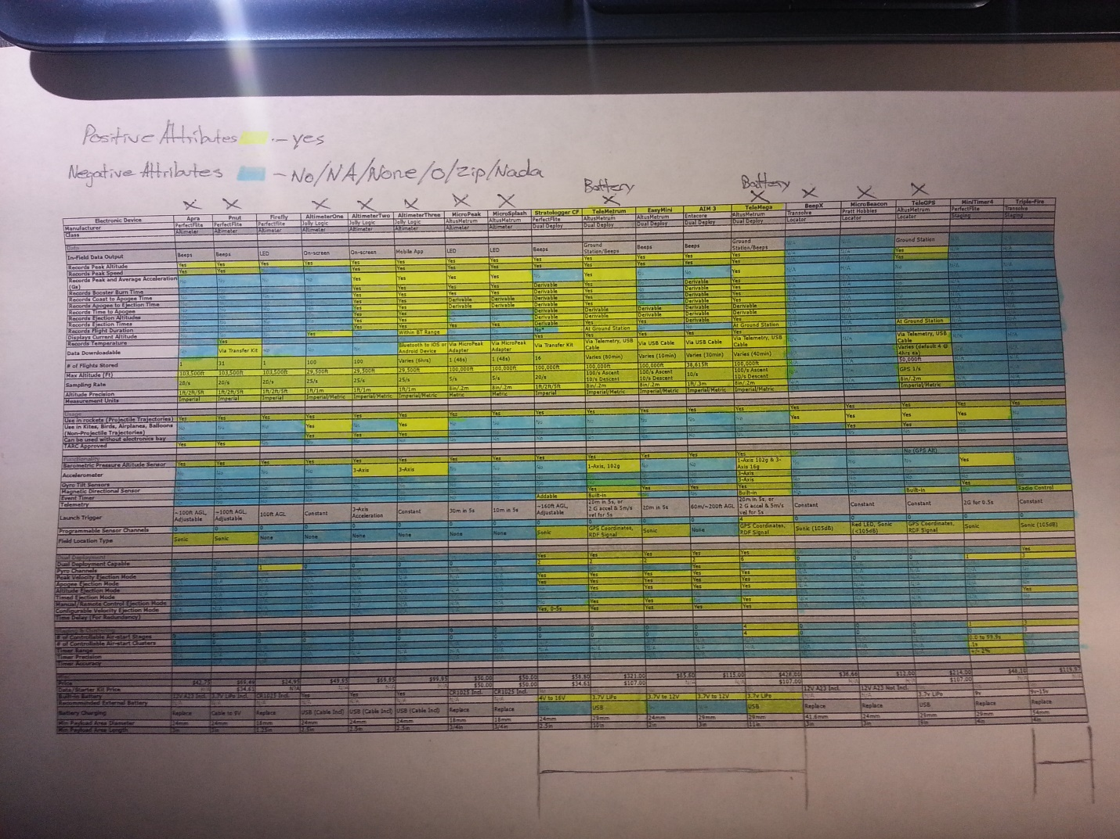

**THIS WEEK**

This week we decide on the final flight computer and begin testing of various electronic systems.